**ITC LAB 7**

**Lab Task. 7.1) Write a program which prints your bio data and also show it**

#include <iostream>

using namespace std;

int main()

{

int a=0;

std::string b;

cout << "Enter your name" << endl;

getline(cin,b);

cout << "Enter your CMS ID" << endl;

cin >>a;

cout << "Your name is " <<b<< endl;

cout << "Your CMS ID is " <<a<< endl;

return 0;

}

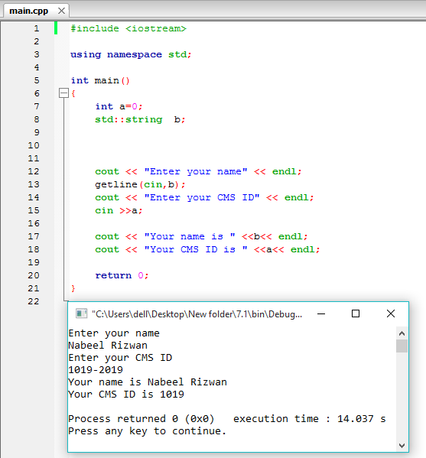

**Lab Task. 7.2) Write a program that prints the table of 8. Sample Output**

#include <iostream>

using namespace std;

int main()

{

int a;

cout << "Tables" << endl;

cout <<"Enter Number"<< endl;

cin >>a;

cout <<a<<" x 1 = "<<a*1<< endl;

cout <<a<<" x 2 = "<<a*1<< endl;

cout <<a<<" x 3 = "<<a*1<< endl;

cout <<a<<" x 4 = "<<a*1<< endl;

cout <<a<<" x 5 = "<<a*1<< endl;

cout <<a<<" x 6 = "<<a*1<< endl;

cout <<a<<" x 7 = "<<a*1<< endl;

cout <<a<<" x 8 = "<<a*1<< endl;

cout <<a<<" x 9 = "<<a*1<< endl;

cout <<a<<" x 10 = "<<a*1<< endl;

cout <<a<<" x 11 = "<<a*1<< endl;

cout <<a<<" x 12 = "<<a*1<< endl;

return 0;

}

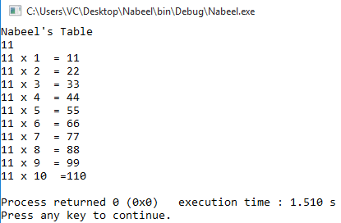

**Lab Task. 7.3) Write a program which reads marks for three subjects and then prints total marks and percentage.**

#include <iostream>

using namespace std;

int main()

{

int a,b,c,d,f;

cout <<"Enter Marks for English" << endl;

cin >>a;

cout <<"Enter Marks for Maths" <<endl;

cin >>b;

cout <<"Enter Marks for Physics" << endl;

cin >>c;

cout<<"Enter Marks for English "<<a<< endl;

cout<<"Enter Marks for Maths "<<b<< endl;

cout<<"Enter Marks for Physics "<<c<< endl;

cout<<"Total Marks are " <<d=(a+b+c)<<endl;

d%300=f

cout<<"Percentage "<<f*100<<endl;

return 0;

}

